EVALUATION REPORT
1.8 & 2.6 THRESHOLD

CONTENT PAGE
- ABSTRACT

- THRESHOLDING APPROACH

- 1.8 Threshold
- 2.6 Threshold

- METRICS AND EVALUATION

- ROC CURVE & AUC

- STREAMLIT DIAGNOSTIC SYSTEM

- CONCLUSION

ABSTRACT
Overview
This report evaluates the diagnostic performance of thermal asymmetry thresholding using a dataset of 167 volunteers, comprising 45 healthy control subjects and 122 diabetic patients. The study investigates the efficacy of using symmetrical temperature differences across four primary angiosomes to identify early-stage risk factors for diabetic foot ulcers.
Methodology
The evaluation utilizes a thresholding system based on the Maximum Asymmetry found among the four plantar angiosomes. Two clinical benchmarks were established:
- 1.8 (Local Risk): A cautionary threshold designed to identify early inflammatory asymmetries.
- 2.8 (Diffuse Risk): A high-severity threshold indicating significant thermoregulatory impairment or active pathology.
Objective
The primary goal was to validate whether these specific thresholds could accurately differentiate at-risk diabetic patients from the healthy control group. By performing a Sensitivity Analysis (ROC Curve) and other evaluation metrics, this report quantifies the trade-off between sensitivity (catching all at-risk cases) and specificity (avoiding false alarms).

THRESHOLDING APPROACH
1.8 THRESHOLD:
To evaluate the diagnostic accuracy of our system, we implemented the Armstrong Threshold of 1.8, a clinically validated biomarker for pre-ulcerative inflammation.
- Ground Truth Labeling: We first established a baseline by encoding our subject groups: the Control Group (CG) was assigned a label of 0, and the Diabetic Group (DM) was assigned a label of 1.
- Logic Implementation: Using the calculated contralateral asymmetry for the four primary angiosomes (LCA, LPA, MCA, and MPA), we applied a "worst-case" logic. A patient was flagged as 1 (At Risk) if the maximum asymmetry in any of the four angiosomes was 1.8. Otherwise, they were classified as 0 (Normal).

Quantitative Findings
Out of the total population of 167 volunteers, the system yielded the following results at the 1.8 threshold:
- Control Group (n=45): 100% of the control group successfully remained below the 1.8 threshold. This indicates a very high Specificity, meaning the system does not produce false negative for healthy individuals.
- Diabetic Group (n=122): 27 patients were correctly identified as being at Local Risk for foot ulcers. 95 patients remained below the $1.8^\circ C$ threshold and were classified as 0.
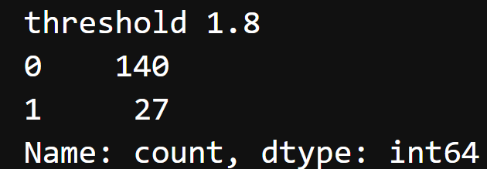
Above shows 140 volunteers which consist of the whole 45 non-diabetic patients and 95 of the diabetic patient which are classified as not having local foot ulcer risk; while the 27 are all diabetic patients successfully classified with the local risk.

2.6 THRESHOLD:
To segment the critical patients from the less criticals, a threshold of 2.6 was carried out.
Still using the same segmenting logic as the 1.8, we gave patients with symmetry values above 2.6 as 1 and the other patients below as 0
Quantitative Findings:
Out of the same plantar sample size of 167, it was discovered that 8 diabetic patients are above the 2.6 set threshold which indicates the critical risk set as (1) and the other 159 patients are classified as 0 which indicate not critical


METRICS AND EVALUATION
An evaluation was carried out on both the 1.8 and 2.6 threshold, Below shows the performance of these different threshold

- 1.8 Threshold Evaluation:

- The classification report provides a comprehensive overview of the system's performance using standard statistical metrics. For this evaluation, the manually labeled "Ground Truth" (Control Group = 0, Diabetic Group = 1) was used as the True Class because diabetic patients have more risk of foot ulcer, while the results generated by our thresholding logic were treated as the Predicted Class.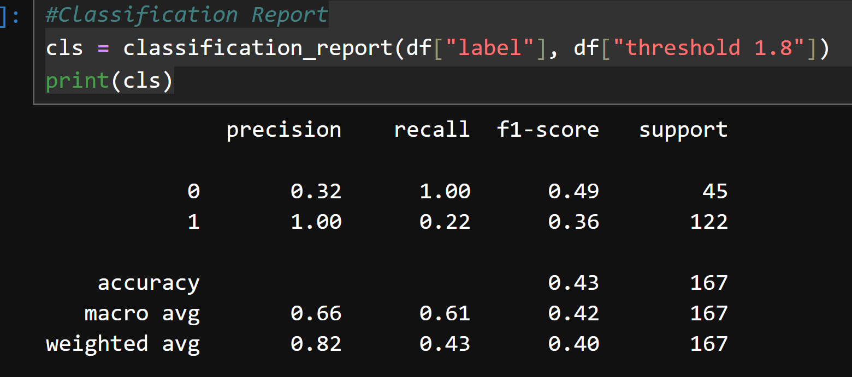

- Accuracy score: For the 1.8 threshold, this metric measures how accurate the threshold is to the true class in this case we got a 43% accuracy which is quite off because of the low number of diabetic patients that have above 1.8 degree symmetry

- Precision score: This metric measures how accurate the threshold is to the true class. in our case, we have a 32% score on class 0 which is because most diabetic patient fall below the threshold which indicate false negatives while we hove a 100% precision score for class 0 because patients that are above the threshold are all diabetic patients. Meaning they are true positives.

- Recall score: This metrics measures how well the logic and threshold segments the class. For class 0 the logic easily gets all control group correctly 100%, while for class 1 the it fails to get 88% of diabetic group over the threshold

- The Confusion Matrix looks at the entire group and checks how well the logic performs in getting the true positives, true negatives, false positives and false negative
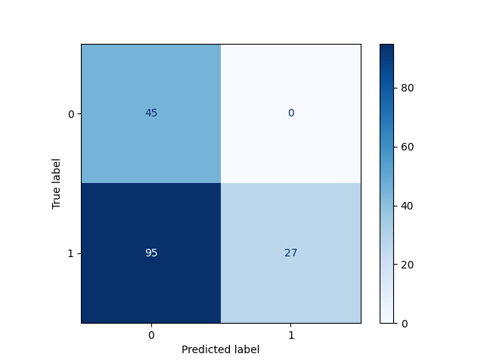

- Top-Left (True Negatives - 45): Healthy people correctly identified as healthy.

- Top-Right (False Positives - 0): Healthy people accidentally flagged as "At Risk.”.

- Bottom-Left (False Negatives - 95): Diabetic patients who were below the threshold.

- Bottom-Right (True Positives - 27): Diabetic patients correctly flagged as "At Risk."

- 2.6 Threshold Evaluation:

  - Classification report: Below entails some key metrics used to evaluate the outcome of the 2.6 threshold
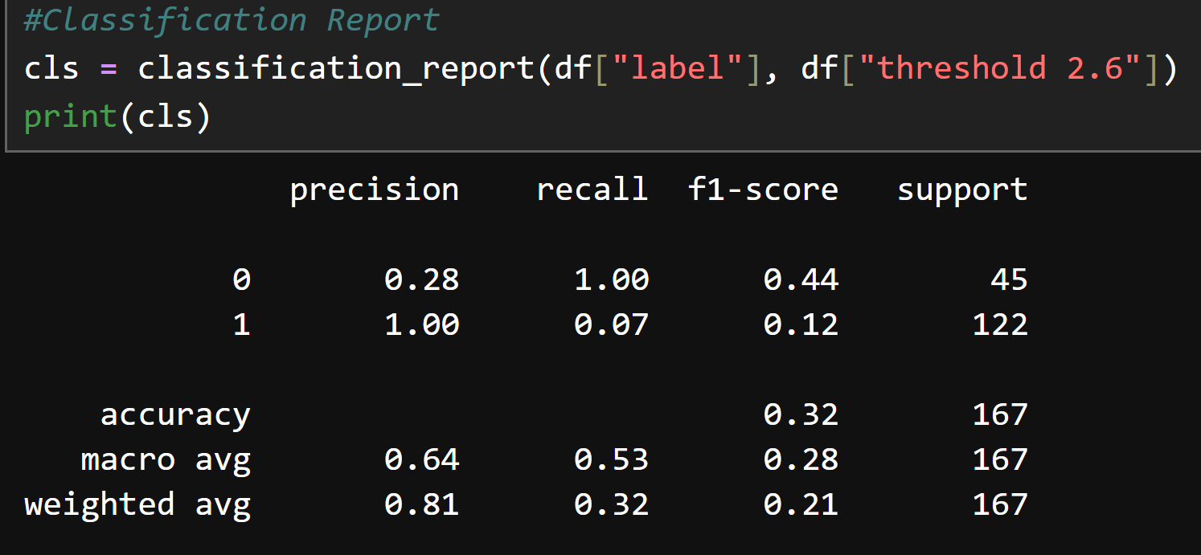

- Accuracy score: This shows a much more lower accuracy 32% which indicates the reliability of this logic in segmenting extreme foot ulcer cases.

- Precision score: unlike the 1.8, 2.6 shows much lower precision score for class 0 28% and still 100% for the class 1. Which indicates this logic still correctly identifies 100% of true positives.

- Recall score: In this dataset sample, the threshold fails to match majority of the class 1 which is the reason we get the 7%

- Confusion Matrix: It checks how well the logic performs in classifying the true positives, true negatives, false positives and false negative.
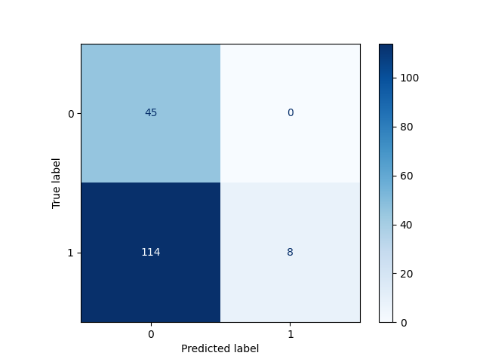

- Top-Left (True Negatives = 45): Just like the 1.8°C threshold, you have successfully identified 100% of the control group. There are zero false alarms.

- Bottom-Right (True Positives = 8): At this higher threshold, only 8 diabetic patients were flagged. These represent the "Critical Risk" group. These are individuals with very high thermal asymmetry, likely indicating advanced neuropathy or high ulcer risk.

- Bottom-Left (False Negatives = 114): Because 2.6 is a very "high bar" to cross, 114 diabetic patients stayed below it. In medical terms, these patients are "negative" for severe asymmetry, even though they have diabetes.
This threshold successfully flags severe cases.

ROC CURVE & AUC
The ROC Curve measures how well the temperature asymmetry "separates" healthy people from diabetic patients across all possible thresholds.
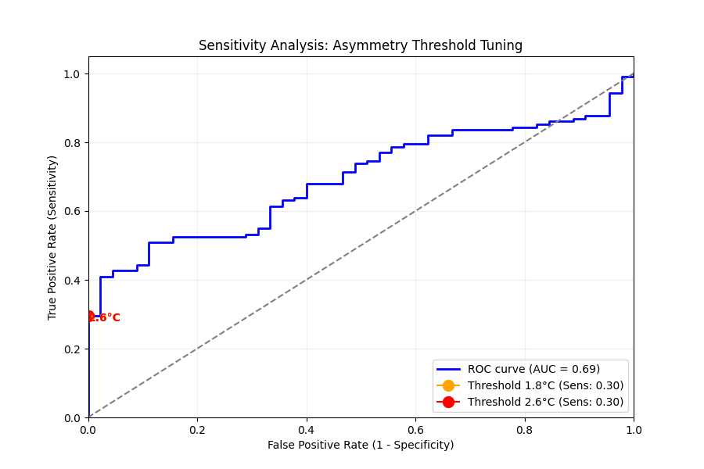
- AUC = 0.69: This is the "Grade.", an AUC of 0.69 represents and shows the fairness of the threshold. It proves that temperature asymmetry is a real physiological marker, it’s significantly better than a random guess (the dashed diagonal line).

- The "L-Shape" at the start: the blue line shoots straight up at the very beginning of the X-axis. This means the system can achieve about 40% Sensitivity while maintaining 0% False Positives. This is a very "clean" signal for a medical test.

- The Threshold Dots: Your 1.8 and 2.6 dots are sitting on the far left. This confirms that the choice of thresholds is extremely conservative. The idea isn’t to catch everyone, but making sure we never lie to a healthy person and same time catch far off cases

STREAMLIT DIAGNOSTIC SYSTEM
For pratical reason, we built an app using python programming and streamlit where an input of the feets and the thermogragh generated csv is inputed and this particular system performs segmentation and foot angiosomes cutting, registration and symmetry logic based on the foot to the csv and output the clinical risk of the patient.

This app classifies users into normal range, warning threshold (1.8) and high risk threshold (2.6)
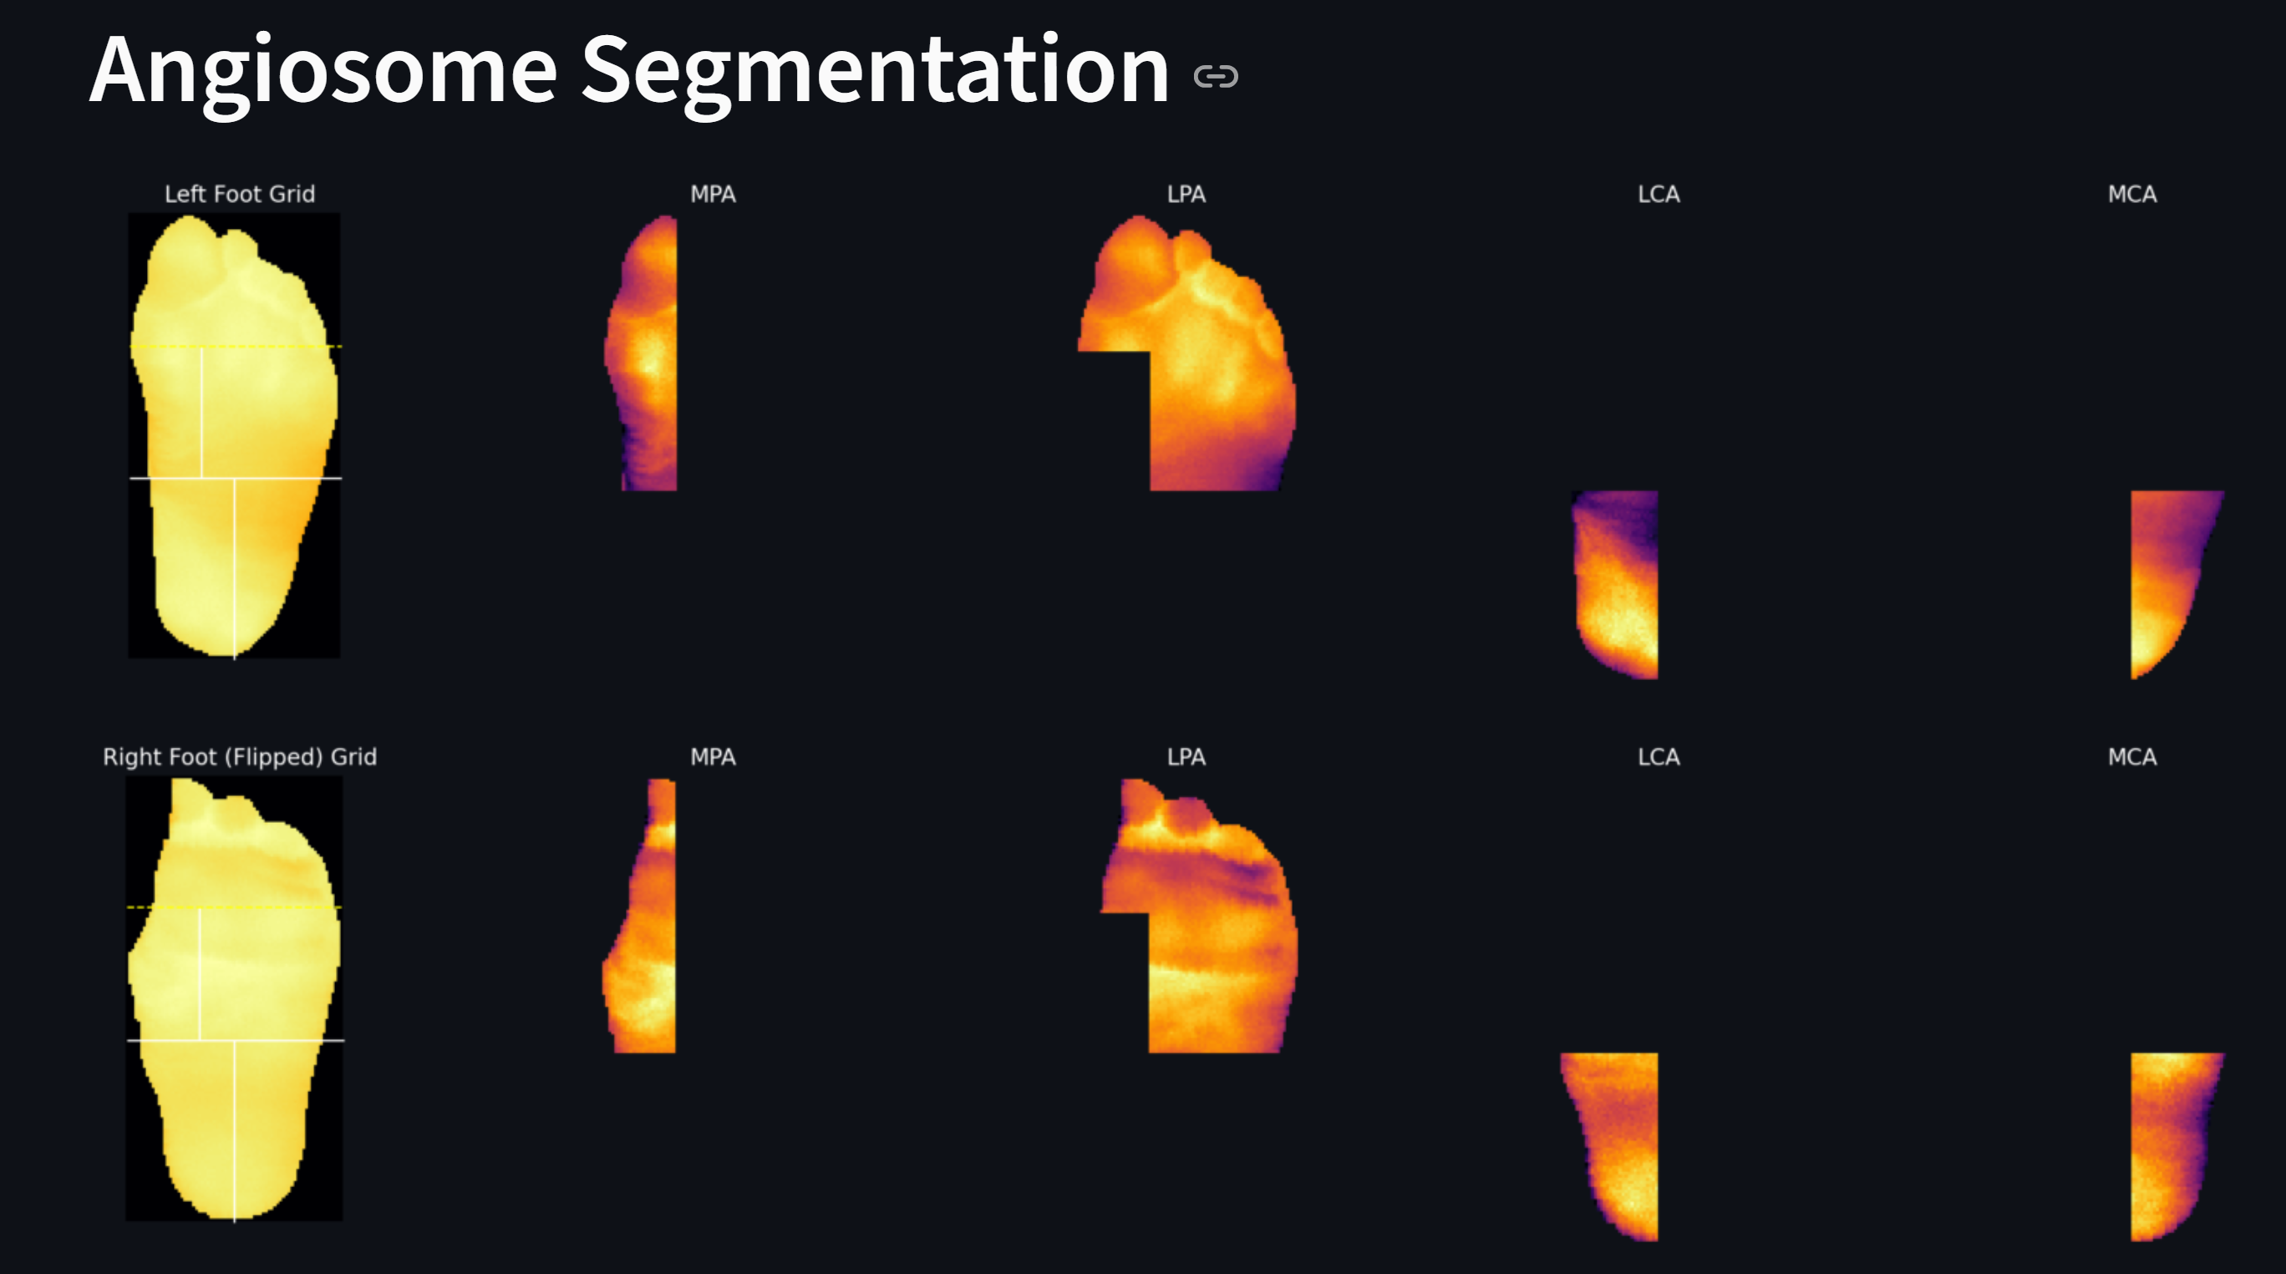
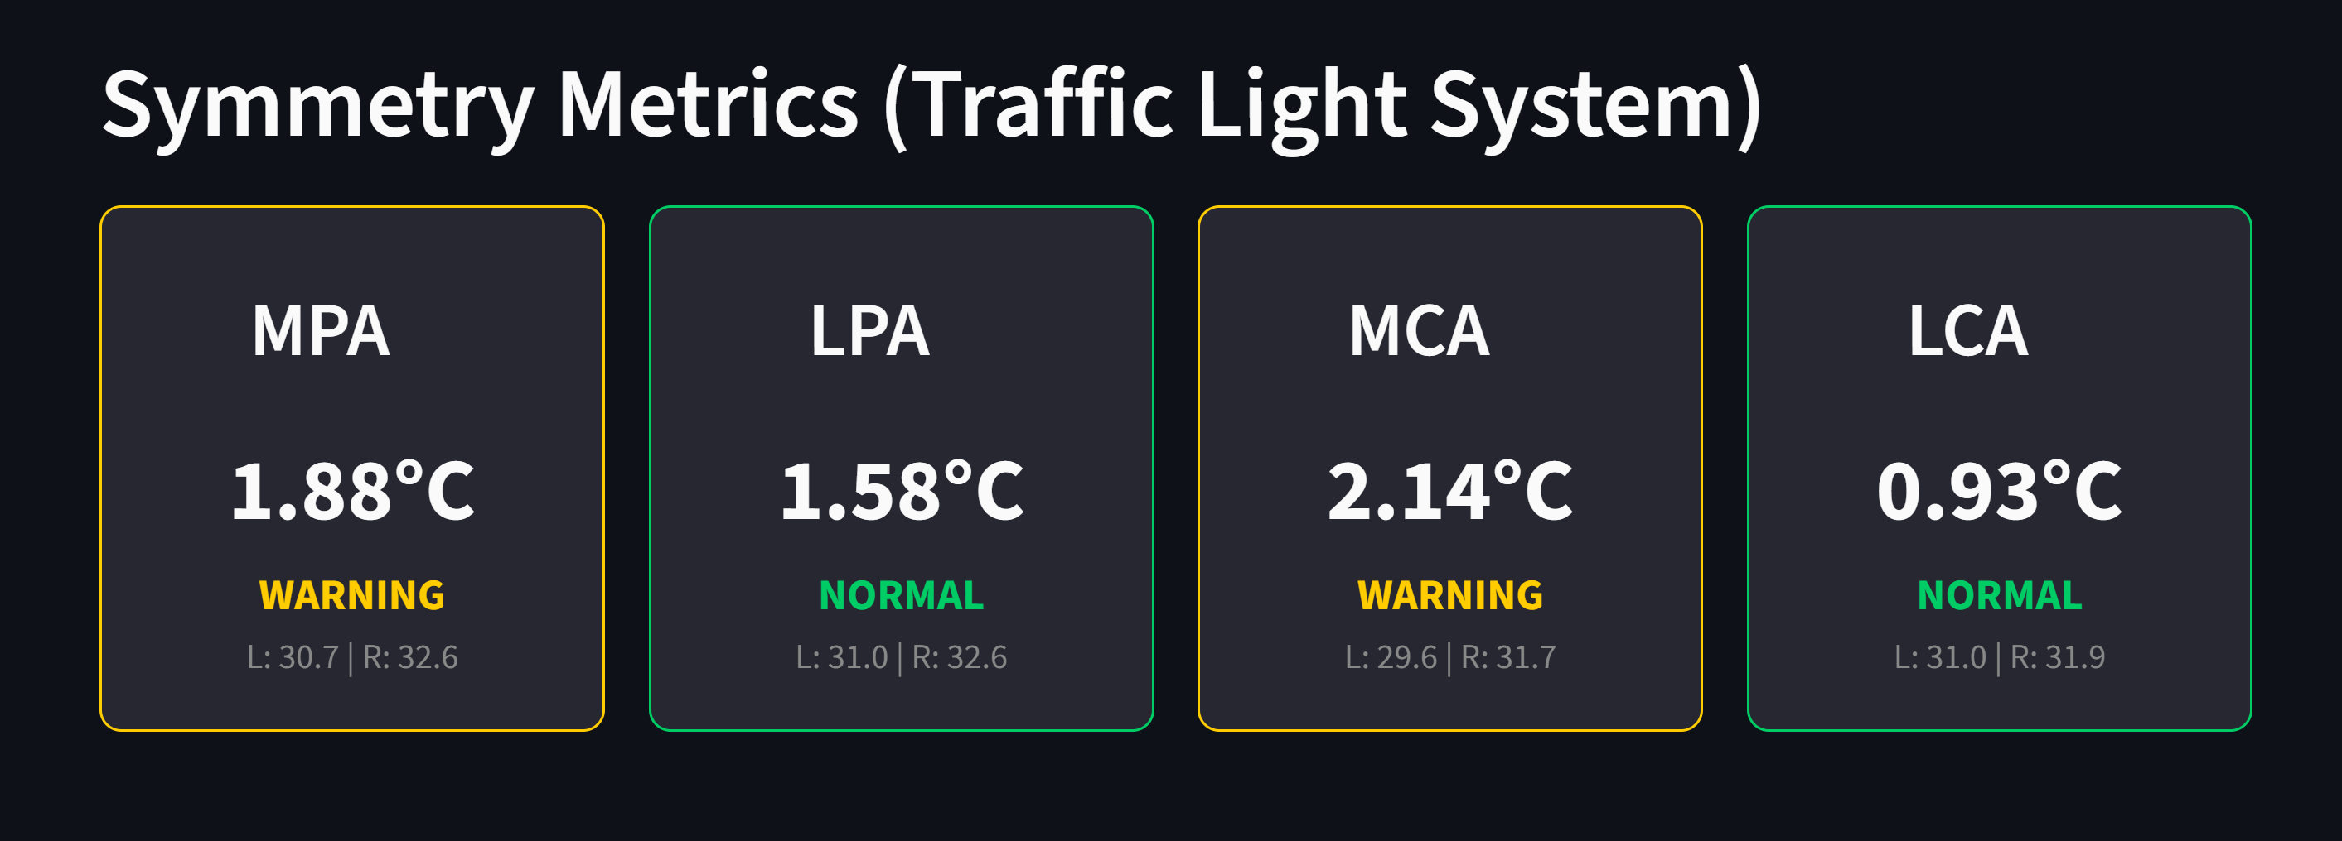

CONCLUSION
This evaluation validates the use of thermal asymmetry as a robust, non-invasive biomarker for detecting pre-ulcerative inflammation in diabetic patients. By operationalizing established clinical thresholds 1.8 and 2.6, we have successfully developed a diagnostic system capable of stratifying patients by risk severity without generating false alarms for healthy individuals.
- Reliability through Specificity: The system achieved a perfect specificity of 100% across all test groups. This ensures that the clinical workflow is not burdened by false positives, making it a dependable screening tool for both primary care and home monitoring.

- Stratified Risk Assessment: The dual-threshold approach provides a nuanced "Traffic Light" system. While the 1.8 Armstrong threshold serves as a sensitive early-warning trigger for localized inflammation, the 2.6 threshold effectively isolates critical pathological cases requiring immediate intervention.

- Operational Integration: The deployment of these findings into a Streamlit-based diagnostic application demonstrates the practical feasibility of automated thermal analysis. By combining precise angiosome segmentation with real-time symmetry metrics, this system provides clinicians with an objective, data-driven dashboard for preventative diabetic foot care.
In summary, while thermal asymmetry alone is not a primary diagnostic for diabetes, it is a highly specific indicator of active inflammatory risk. This system offers a significant advancement in preventative diagnostics, potentially reducing the incidence of diabetic foot ulcers and subsequent amputations through early, automated detection.

